Chapter 14, Solution 86.

Using Fig. 14.103, design a problem to help other students to better understand how to use PSpice to obtain the frequency response (magnitude and phase of I) in electrical circuits.

Although there are many ways to solve this problem, this is an example based on the same kind of problem asked in the third edition.

Problem

Use PSpice to provide the frequency response (magnitude and phase of i) of the circuit in Fig. 14.103. Use linear frequency sweep from 1 to 10,000 Hz.

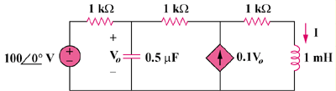

Figure 14.103

Solution

The schematic is shown below. A current marker is inserted to measure I. We set Total Points = 101, start Frequency = 1, and End Frequency = 10 kHz in the AC sweep box. After simulation, the magnitude and phase plots are obtained in the Probe menu as shown below.

